###### C:\Users\rashmi.phalnikar\Desktop\MIT-WPU-Logo.png-

End-Term Project Report

on

###### Securing Your Home with IOT: A Smart Security System

**Project Members**

PF12 Amir Shakeel

1032200623

PF24 Ankit Kumar

1032201304

PF30 Swayam Sharma

1032201710

PF43 Parth Mogadpally

1032202204

**Under the Internal Guidance of**

Prof. Umesh Raut

###### School of Computer Engineering and Technology MIT World Peace University, Kothrud,

###### Pune 411 038, Maharashtra - India

###### 2022-2



SCHOOL OF COMPUTER ENGINEERING AND TECHNOLOGY

C E R T I F I C A T E

This is to certify that, Ankit Kumar, Swayam Sharma

Parth Mogadpally

Amir Shakeel

of BTech.( Computer Science & Engineering) have completed their project titled “*Securing Your Home with IOT: A Smart Security System”* and have submitted this Mini Project Report towards fulfillment of the requirement for the Degree- Bachelor of Computer Science & Engineering (TY. BTech-CSE) for the academic year 2022-2023.

|  |  |  |  |
| --- | --- | --- | --- |
| **[Dr/ Prof.** | **Umesh Raut]** |  | **[Dr. Vrushali Kulkarni]** |
| Project Guide |  |  | Program Head |
| School of CET |  |  | School of CET |

MIT World Peace University, Pune MIT World Peace University, Pune

Internal Examiner:

External Examiner:

**Date:**

Acknowledgement

We express our deep gratitude to **Dr.Umesh Raut**, Assistant Professor, Department of Computer Science & Engineering for her valuable guidance and suggestion throughout my project work.

We would like to extend our sincere thanks to **Prof. (Dr.) Vrushali Kulkarni**, Head of Department, for her time to time suggestions to complete our project work. We would also like to thank our families and friends, who helped us in every possible way.

Name of the Students

Amir Shakeel

PF12

Ankit Kumar

PF24

Swayam Sharma

PF30

Parth Mogadpally

PF43

# Abstract

Internet of Things (IoT) conceptualizes the idea of remotely connecting and monitoring real world objects (things) through the Internet [1]. When it comes to our house, this concept can be aptly incorporated to make it smarter, safer and automated. This IoT project focuses on building a smart wireless home security system which sends alerts to the owner by using Internet in case of any trespass and raises an alarm optionally.

Besides, the same can also be utilized for home automation by making use of the same set of sensors . The leverage obtained by preferring this system over the similar kinds of existing systems is that the alerts and the status sent by the WIFI connected microcontroller managed system can be received by the user on his phone from any distance irrespective of whether his mobile phone is connected to the internet . We are using PIR sensor to detect motion and through raspberry using internet it will notify the owner.

# List of Tables

|  |  |  |
| --- | --- | --- |
| 1. | Literature Survey…………………………………… | 9 |

# Contents

Abstract I

List of Figures II

List of Tables III

|  |  |  |  |  |
| --- | --- | --- | --- | --- |
| 1 | Introduction | | | 8 |
|  | 1.2 | Unlock the Benefits of IoT-Based Smart Security | | 8 |
|  |  | 1.2.1 | Stay Connected with Smart Security | 8 |
| 2 | Literature Survey | | | 9 |
| 3 | Problem Statement | | | 10 |
| 4 | Project Requirements | | | 12 |
| 5 | System Analysis Proposed Architecture/ high level design of the project | | | 13 |
| 6 | Project Plan | | | 15 |
| 7 | Implementation | | | 17 |
| 8 | Conclusion | | | 21 |
| 9 | References | | | 22 |

Chapter 1 Introduction

Unlock the Benefits of IoT-Based Smart Security

* The Internet of Things (IoT) has revolutionized the way we think about security. IoT- based smart security systems are the perfect way to keep your home safe and secure. With sensors that track movement and notify the owner of the house, you can rest easy knowing your home is being monitored. Plus, when something is detected, the system can start a live camera feed to give you a real-time view of what’s happening.
* IoT-based smart security systems are also easy to install and maintain. With a few simple steps, you can have your home monitored and secure within minutes. Plus, you can customize the settings to fit your needs, so you can be sure your home is always safe and secure.

Stay Connected with Smart Security

* With IoT-based smart security systems, you can stay connected with what’s happening in your home. You can receive real-time notifications when something is detected, so you can take action right away. Plus, you can access the live camera feed from anywhere, so you can keep an eye on your home even when you’re away.
* IoT-based smart security systems also offer peace of mind. You can rest easy knowing your home is being monitored and that you’ll be notified if something is detected. Plus, you can customize the settings to fit your needs, so you can be sure your home is always safe and secure.

Chapter 2 Literature Survey

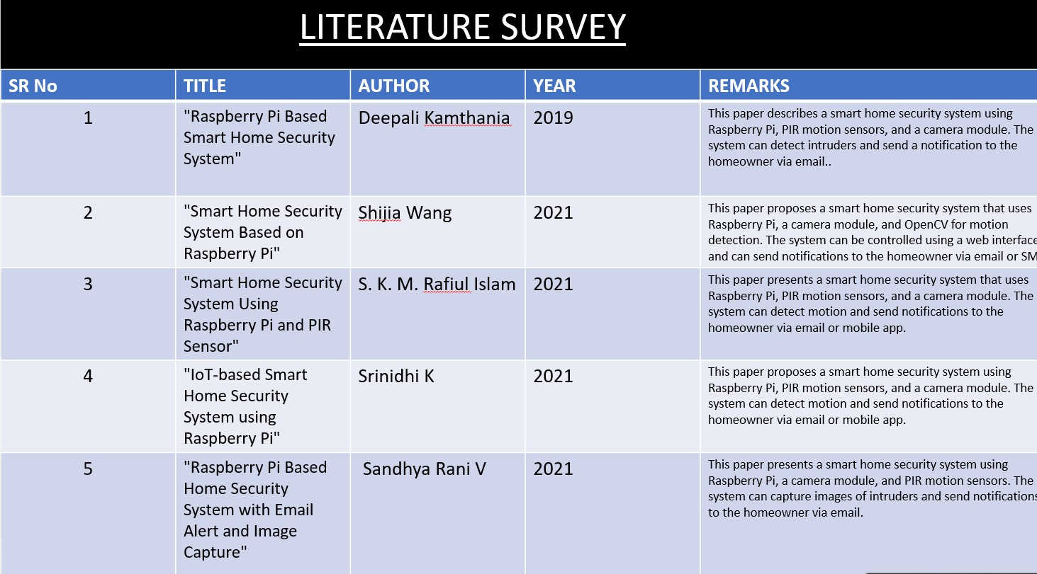

Chapter 3

Problem Statement

#### Securing Your Home with IOT: A Smart Security System

##### Project Scope

* We can use commercialize it as smart doorbell system for homes . It will secure the house. IoT-based smart security systems are also easy to install and maintain. With a few simple steps, you can have your home monitored and secure within minutes. Plus, you can customize the settings to fit your needs, so you can be sure your home is always safe and secure.

The Internet of Things (IoT) has revolutionized the way we think about security. IoT-based smart security systems are the perfect way to keep your home safe and secure. With sensors that track movement and notify the owner of the house, you can rest easy knowing your home is being monitored. Plus, when something is detected, the system can start a live camera feed to give you a real-time view of what’s happening

##### Project Limitations

The only demerit this system has is it will notify the user hundred of times due to movement detected of known person(not intruders) or animal or person just walking by your door.

##### Project Objectives

* IoT-based smart security systems offer a range of benefits for homeowners. With real-time notifications and a live camera feed, you can stay connected with what’s happening. Plus, you can customize the settings to fit your needs, so you can be sure your home is always safe and secure.
* With an IoT-based smart security system, you can enjoy peace of mind knowing your home is being monitored and that you’ll be notified if something is detected. Plus, you can access the live camera feed from anywhere, so you can keep an eye on your home even when you’re aw
* Resources

Hardware- Raspberry pi

PIR sensor Wires

Wifi Camera

Chapter 4 Project Requirements

Memory card/usb drive Jump wires

Usb wifi module

Chapter 5

System Analysis Proposed Architecture/ high level design of the project

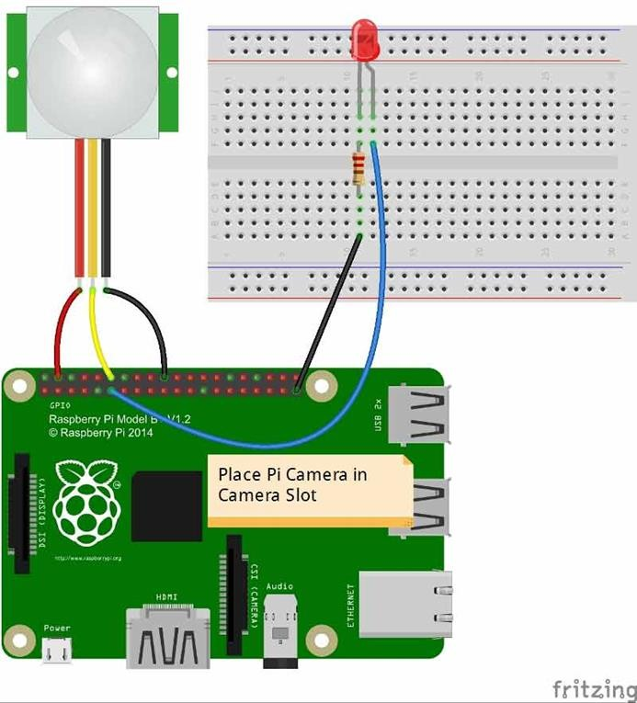

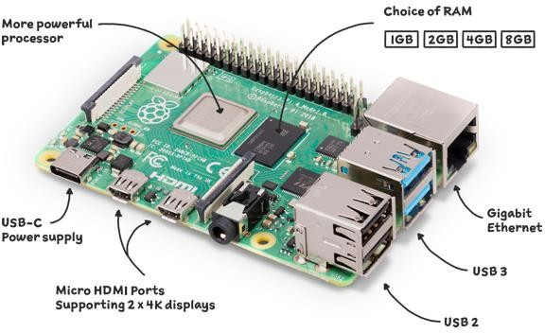

## Chapter 6. Project Plan



##### STEPS-

##### 1.Setting Up Your Hardware Device

##### 2.SETTING UP YOUR RASPBERRY PI WITH RASPBIAN OS like you need to install Raspbian on your micro sd card that you will be using in your Raspberry Pi.

##### 3. INSTALL OPENCV AND REQUIRED LIBRARIES

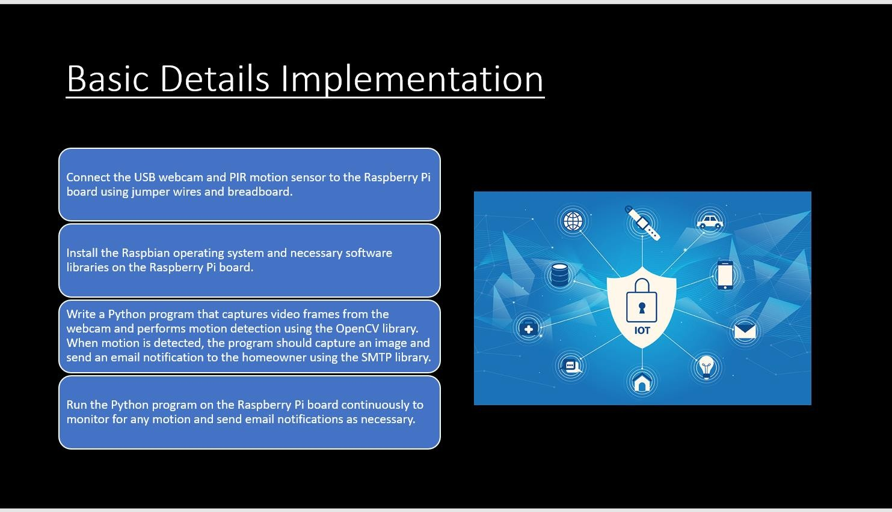

## Chapter 7 Implementation (If done)

### System Architecture and Design

##### Raspberry Pi running Raspbian

##### USB Camera

##### PIR Sensor

##### USB Wi-Fi Module for internet access ( optional, if you connect your Ethernet cable for internet, USB Wi-Fi Module is not needed )

##### Power Adapter to power the Rsapberry Pi

### Methodology/Algorithms used

STEPS:

* 1.Setting Up Your Hardware Device
* 2.SETTING UP YOUR RASPBERRY PI WITH RASPBIAN OS like you need to install Raspbian on your micro sd card that you will be using in your Raspberry Pi.
* 3. INSTALL OPENCV AND REQUIRED LIBRARIES



### Basic Details Implementation

Chapter 8

Conclusion

In conclusion, an IoT-based smart security system using Raspberry Pi, webcam, motion detection, and email notification is a cost- effective, efficient, and scalable solution for improving home security. The system can be easily installed without professional help, and it can be accessed remotely from anywhere with an internet conn

**Chapter 9**

References

1. https://raspberrypihq.com
2. M. Al-Kuwari, A. Ramadan, Y. Ismael, L. Al-Sughair and A. Gastli, "SmartHome Automation using IoT-based Sensing and Monitoring Platform," IEEE, 2018.
3. S. Tanwar, P. Pately, K. Patelz, S. Tyagix, N. Kumar and M. Obaidat, "An Advanced Internet of Thing based Security Alert System for Smart Home," IEEE, 2017.
4. R. Khana and U. Usnul, "Rancang Bangun Sistem Keamanan Rumah Berbasis IoT dengan Platform Android," Ejournal Kajian Teknik Elektro Vol.3 No.1, pp. 18-31, 2018
5. D. Yendri and R. E. Putri, "Sistem Pengontrolan Dan Keamanan Rumah Pintar (Smart Home) Berbasis Android," pp. 1-6, 2018.

**Plagiarism Report**

